Project Work

**Task1 :- Host a static Website on Linux VM**

**STEP 1. CREATING YOUR AZURE ACCOUNT**

Make sure you already have azure account. If not, please create your account on the [azure website](https://azure.microsoft.com/en-us/free).

**STEP 2. CREATING YOUR LINUX VM**

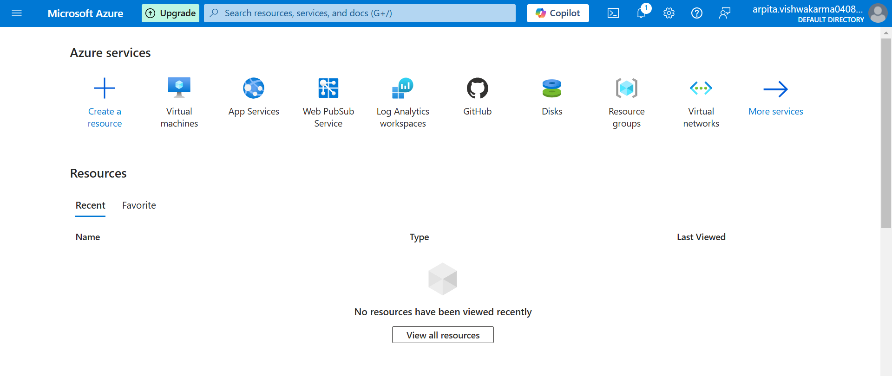

· In the Azure portal, click virtual machine.



· Click create > Azure Virtual Machine.****

**BASIC TAB**

· Resource group > create new

· Virtual machine name --fill in your vm name freely  
· Region -- location of the vm   
· Availability options -- leave default  
· Security type -- leave default  
· Image --operating system used, here I use ubuntu server 20.04 LTS  
· Size -- the size of the specifications of the vm used  
· Authentication type -- SSH public key -- username

· SSH public key source - key pair name (fill in whatever you want)

**OTHER TAB**

Leave all tab as default



Click Review + create then click create if everything is ok.



**STEP 3. CONNECTING TO AZURE FROM WINDOWS USING SSH KEY**

Install putty first if you’re using windows : <https://www.putty.org/>



Open puttygen, it’s located in local C:\Program Files\PuTTY.



**STEP 4. SETTING UP YOUR WEBSITE**





After that, you need to configure inbound port rules. Go back to your Azure portal, click on your vm and go to networking.





Finally, your website is live.